***Movement Options***

Flowing, precise movement is vital in a platformer game, and even more so in a speed-based game. It is vital that movement feels natural to the player, and success and failures of the past can show this.

**Bubsy 3D**

Bubsy 3D is an exact example of 3D movement done badly. The player only moves in the direction they are facing and is slowly turned using the control stick. The lack of movement in an axis separate from the camera causes the game to feel sluggish, despite the player not having momentum and stopping instantly when the button is released, and time is wasted by the player slowly rotating a bobcat to reach the next platform.

**What can we learn from this?**

Multi-directional movement is key. The player’s actions should be able to flow into each other naturally, without having to stop to make any key changes. Dead time walking around is to be avoided, as is control design that promotes frustrating interaction-based difficulty, as opposed to difficulty stemming from level design.

**Super Mario Odyssey**

Mario Odyssey has very fluid 3D movement. Mario has freedom of movement in all directions, and his multiple special moves are available at one button press, where mistakes made feel like the player’s fault, and not the result of bad design choices.

**What can we learn from this?**

Having special moves that do not affect movement, or effect movement in a very minor way, is important. The small momentum reduction when Mario throws his cap is a great example of this. It allows other movement options, such as the dive, to combo out of it, and allows for quick movement adjustment as a correction tool. This can be used in the development of aerial attacks in our game, stalling a player’s fall slightly to allow correction and other moves, such as a hookshot attack. Other movement options, such as the double and triple jump, are key examples of how combo-based movement is satisfying for the player. It is important that we develop a movement system that allows for different combinations of moves without feeling sluggish.

**How will this be done?**

The player will have momentum. Moving quickly in one direction only to turn in the other direction can be jarring if instant and feels unnatural to the player. The player will have influence over the player’s momentum through the controls, but the influence should be limited to ensure that movement feels natural. Jumping is a sharp increase in momentum upwards, and the player’s jumping arc comes from the gradual decrease in that momentum due to gravity, before falling in the opposite direction

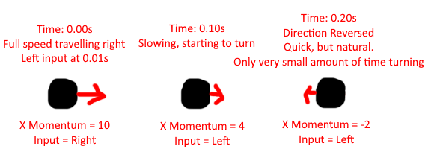

*An example of momentum in action*

Aerial Movement

Sprint button/Slowdown option

Stalling in midair, jump, glide, combo options

Terminal Velocity, max speeds for objects

Carrying momentum from rail and slide effects

Enemy collision and effects on speed